|  |  |  |  |  |  |  |  |  |
| --- | --- | --- | --- | --- | --- | --- | --- | --- |
| |  | | --- | | C:\dev\CoderDojo-Porirua\images\From Flickr\catherinecronin_8687379036.jpg  CC BY-NC-SA Catherine Cronin http://www.flickr.com/photos/catherinecronin/8687379036/in/photostream | | SunDAY 5 May 3:30–4:30 PM  Coder Dojo Porirua  CoderDojo is a global collaboration providing free and open learning to young people, especially in programming technology. C:\Users\Leigh\dev\CoderDojo-Porirua\images\CoderDojo-Porirua-logo\logo-fern_inverted.png<http://www.facebook.com/CoderDojoPorirua> | |  | |  | |  | | --- | | 5 May 20133:30 – 4:30 pmFirst Meet upTEACHING Kids how to CODE!Bring your parentsAnd a laptop if you have oneBe cool! | |  | | Location: Splice Group Offices, Bridgepoint Level 1, 17 Marina View, Mana, Porirua | |

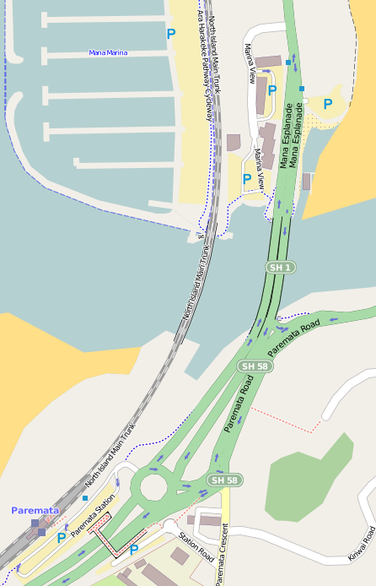

Coming from Paremata Station Roundabout, take North exit on SH1, travel over bridge and take 1st left into Marina View.

Follow road around to parking at South end of Marina View.

We’re one the 1st floor, directly above Curves Gym.

Contact:

Leigh 021 271 1844